**General Test Method for Burst Testing**

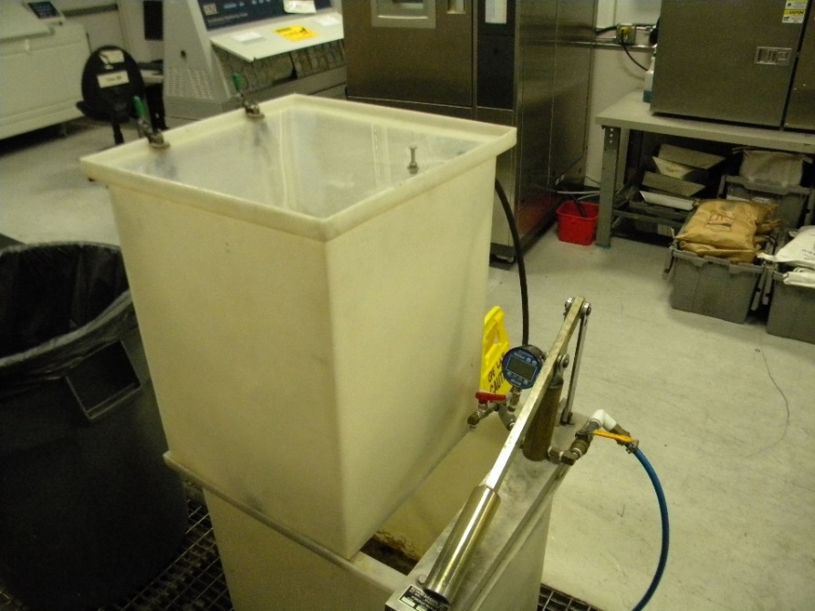 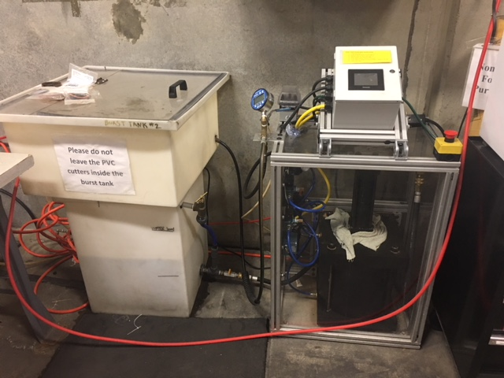

CONTENTS

Equipment 3

1.1 Calibrated Pressure Gauge 3

1.2 Manual Burst Pressure Tank 3

1.3 Automated Burst Pressure Tank 3

2 Software 3

3 Setup 3

3.1 Manual Burst Tank Setup: 3

3.2 Automated Burst Tank Setup 3

4 General Test Procedure 4

4.1 Manual Burst Testing 4

4.2 Automated Burst Testing 5

5 Data Format and Reporting 7

Equipment

The Following Equipment is required for this testing:

* 1. Calibrated Pressure Gauge
     1. The pressure gauge must be calibrated and have a minimum pressure capability of 2000 psi.
  2. Manual Burst Pressure Tank
     1. Test tank must be capable of increasing pressure, which includes a hydraulic pump, plumbing, high pressure lines, and check valves. The system must be capable of safely pressurizing product to 2000 psi.
  3. Automated Burst Pressure Tank
     1. Test tank must be capable of increasing pressure, which includes a hydraulic pump, plumbing, high pressure lines, check valves, and microprocessors. The system must be capable of safely pressurizing product to 2000 psi.

1. Software

None Required

1. Setup
   1. Manual Burst Tank Setup:

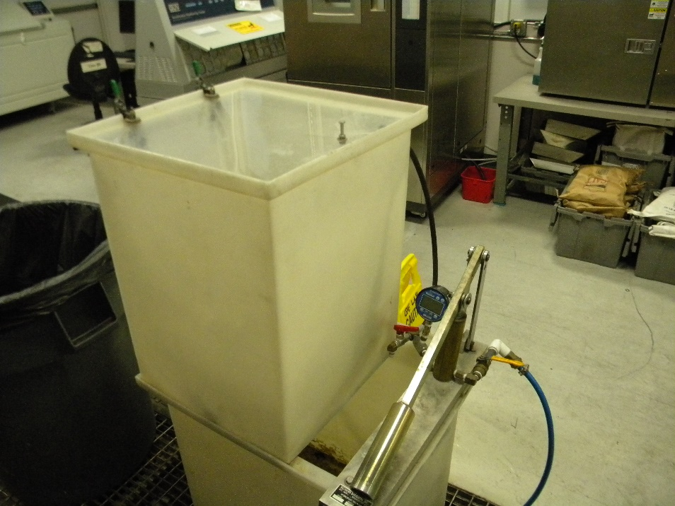

* + 1. Parts Needed: Manual Burst Tank
  1. Automated Burst Tank Setup



* + 1. Parts Needed: Automated Burst Tank

1. General Test Procedure
   1. Manual Burst Testing
      1. Mount the product to the burst tank. Mounting includes an ability for the product to be capped fully, creating a pressure vessel, i.e. using a cap to cap the outlet of the product.
      2. Allow water to flow through the product, for example, open or energize the solenoid to allow water to flow through the entire valve *(Fig 1)*.

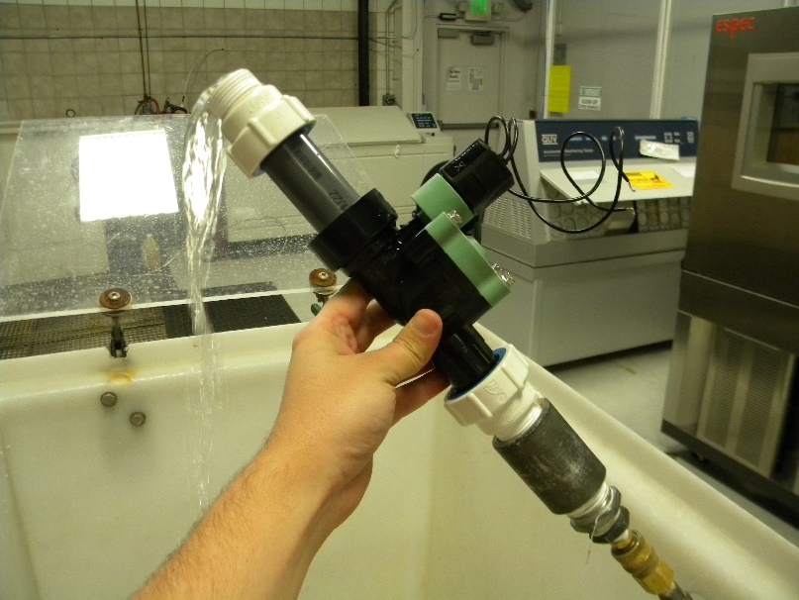

*Figure 1: Purge air from product and lines.*

* + 1. Turn water flow off and prevent water from flowing out of the product.
    2. Cap the end of the product, creating a pressure vessel.

**SAFETY: Product must be completely within an enclosure to prevent injury.**

* + 1. Using the hydraulic pump, slowly increase pressure, no more than 50 psi/second *(Fig 2)*.

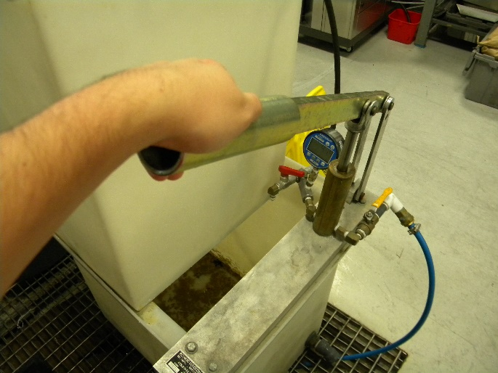

*Figure 2: Pressurize the product.*

* + 1. Continue to increase the pressure until the product fails or until the maximum allowable pressure for the system is reached.
    2. Record the pressure and location on the valve at which failure occurs.
  1. Automated Burst Testing
     1. Power on the control module *(Fig 3)*.

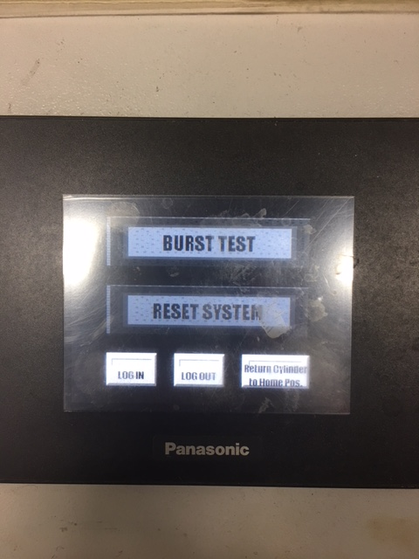

*Figure 3: Home screen*

* + 1. Press the “BURST TEST” button.
    2. Enter the login password.
    3. Follow the pre-purge instructions *(Fig 4)*.

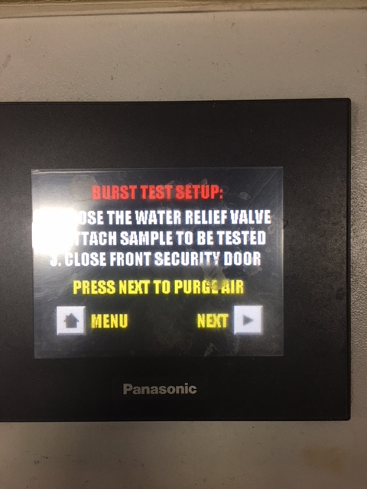

*Figure 4: Pre-purge prompt*

* + 1. Purge the air from the sample *(Fig 5)*.

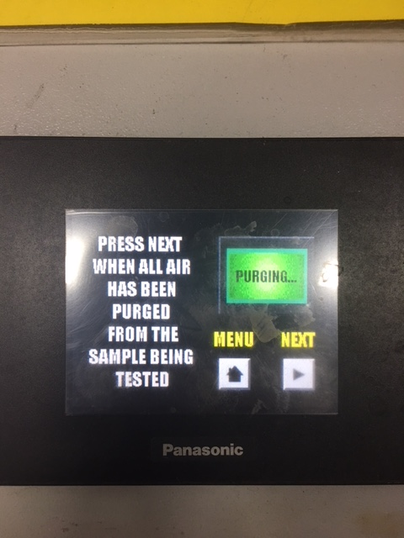

*Figure 5: Purge air from the product*

* + 1. Click “NEXT” and cap the end of your product, if applicable, to create a pressure vessel.
    2. Close the lid, reset the pressure gauge, and prepare for burst *(Fig 6)*.

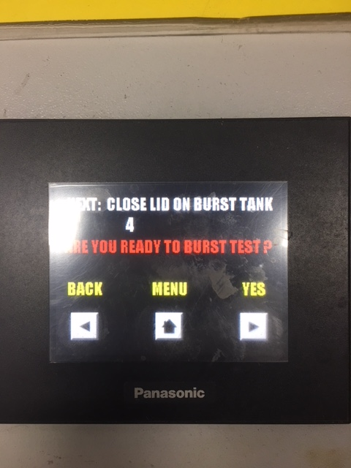

*Figure 6: Prepare for burst*

* + 1. Click “YES” and the burst test will start *(Fig 7)*.

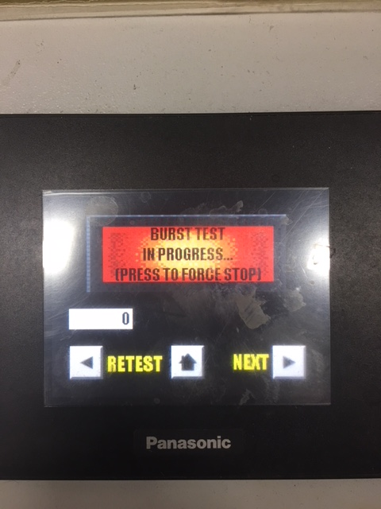

*Figure 7: Burst test in progress*

* + 1. Once the product bursts, the test will automatically stop *(Fig 8)*. Check the max pressure on the pressure gauge to see at what pressure the product failed and record this value.

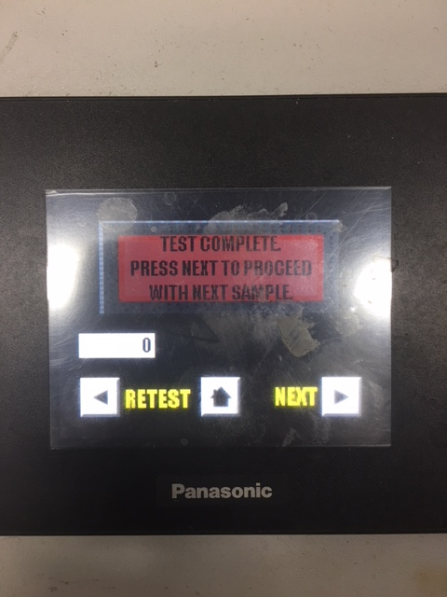

*Figure 8: Burst Test Complete*

* + 1. Click “NEXT”. You can now remove the product from the test tank and prepare the next sample if applicable. If sampling is done, select the “NO!” button. This will take you back to the home screen. From there you can log off and shutdown.
    2. Repeat steps 4.2.4-4.2.10 from additional samples.

1. Data Format and Reporting
   * 1. Record the pressure at which the product fails.
     2. Record the location of the failure
     3. Example
        1. Sample 1: 851.7 psi (lid fracture)

* END *